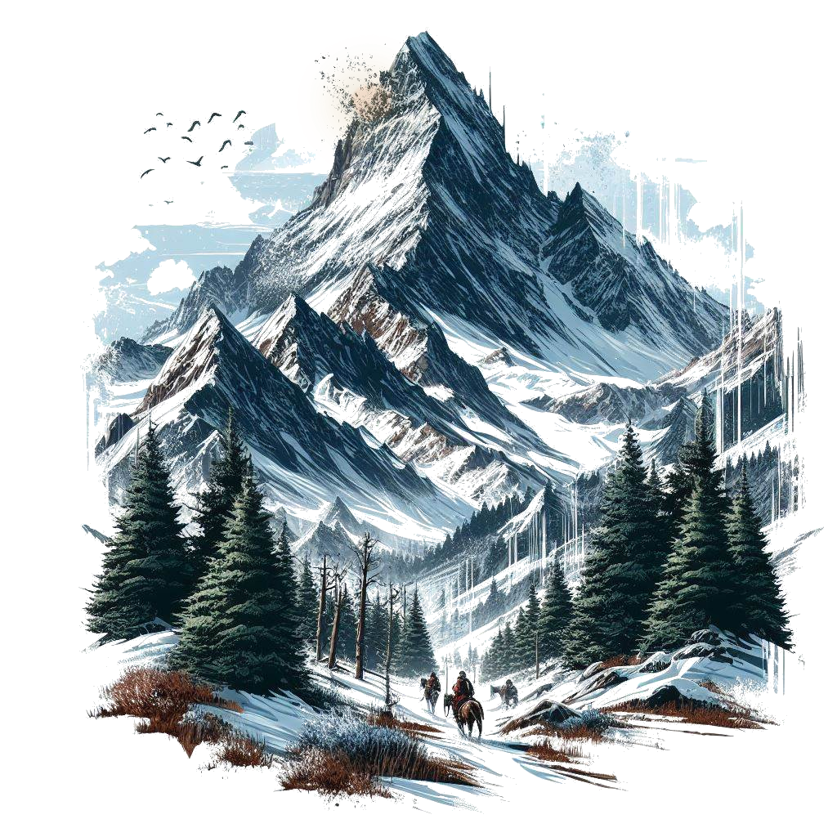







# Title Gradient 6Chapter Section

Welcome, Game Master! This book is for your eyes only. It contains the QuestGuard starter one-shot Fire on Mount Hyhelm, with instructions on how to play and organize this story for your players.

If you are not a Game Master, close this book immediately.

## Who Is This for

This book is intended for beginner Game Master and players who have never played QuestGuard. It was made to be as easy as possible to run.

If you have never been a Game Master, now is your chance.

## What To Expect

Fire on Mount Hyhelm follows a group of 3 to 5 players, on an adventure that will last one single session, start to finish (3 to 5 hours). Of course, you can do the adventure in multiple sessions, depending on the time you want to spend playing.

As a Game Master, you are **not required to read this book in advance**. Fire on Mount Hyhelm was made to be **read at a glance** - it requires minimal preparation. However, please read everything up until Chapter 1

before you begin, to learn how to use this book. Once you get to Chapter 1, simply let the book guide you.

The book contains many read-aloud sections, and flows top-to-bottom, left-to-right and will guide you through everything you need to say and do.

This adventure also teaches the players the basic rules of QuestGuard.

## Your Responsibility

As a Game Master, you will be the narrator and referee of the game. You present situations, and players will try to do things in those situations. A lot of the times, a **Check** is required (a roll of a die) to determine if the player succeeds in their action.

You will be responsible for reading passages out loud for your players, roleplaying as non-player characters (e.g. speaking in the voice of another character or conveying what they are saying), controlling the monsters in fights (e.g. rolling dice for them) and, usually, making sure every player gets their time in the spotlight and is having a good time.

# Title Gradient 6How to Read It

This section explains how to read the book and interpret the various elements.

## Read-Alouds

When you encounter text with a tan background like this one, read it out loud for the players. For example:



*You come across a narrow river that blocks your*

*path forward. The river smells of salt, thick muck*

*flows through it. What do you do?*

There will be a lot of these and they will narrate not just story elements, but also rules.

As a Game Master, **a lot of the information you have is from read-alouds**. These read-alouds will serve as information for both you and the players.

## NPC Replies

In some sections, NPC’s (non-player characters from the story) will have potential replies to say. Here is an example for a random peasant players encounter:



***“****Welcome to our village, adventurers!”*

***“****You look hungry. Head over to the tavern, they*

*serve good food!”*

***…****I did see* ***a strange man******in the******woods*** *last night!*

*…No, I never* ***stole*** *anything in my life! [lie,*

*he stole coins from the church donation box]*

You will see read-alouds with NPC replies.

The first few lines, in quotes, are dialogue lines meant to be **said directly** by the NPC (e.g. casually mentioning them in a conversation). For example, say the first dialogue line, wait for the players’ response, and if you see fit, say the next dialogue line. Rinse and repeat.

Lines starting with **…** are meant to be **only answers to questions** players ask, and should not be given without being asked specifically about the subject.

**Bold** phrases or words are emphasized to easily come into your view in case players ask about it.

If an NPC has no dialogue lines about a subject, then they don’t know about it.

## NPC’s - When In Doubt…

When in doubt of what an NPC would say, resort to them saying *“I don’t know” or a similar reply*.

Don’t worry - you will get good information on NPC’s that is easily readable at a glance, without requiring preparation. Feel free to paraphrase NPC dialogue lines.

## Suspicion (0 to 20)

Each NPC has a secret **Suspicion** level from 0 (is completely friendly and trusts the players) to 20 (will not even talk to the players or is outright hostile).

Whenever the players try to persuade an NPC and the NPC isn’t sure of what to do, have the players roll a Charisma Check at least equal to the NPC’s Suspicion.

On a successful Check, decrease **Suspicion** by 1. Otherwise increase it by 1.

If players say something insulting or fitting to the conversation, increase or reduce Suspicion by 1.

Keep track of the NPC’s **Suspicion**.

Depending on how mild or crazy the player’s idea is, feel free to secretly give a +5 or -5 to their Check.

Decreasing **Suspicion** will unlock certain dialogue lines

# Title Gradient 6Locations & Sections

The book’s chapters function as Locations.

Each “chapter” is a separate Location that contains read-alouds, artwork, scenarios, etc.

Here is an example:

# Title Gradient 6The Windmill

*As you ascend the winding cobblestone path, you*

*approach a decrepit fence. Pushing through the*

*rotting wood, you arrive at the entrance of an old*

*wooden windmill, now reclaimed by nature,*

*overgrown with vegetation. The air carries a*

*musty scent, tinged with the earthly smell of*

*decaying wood, hinting that has been standing for*

*centuries, untouched by human hands in many*

*decades.*

## If Sections

Some sections are titled “If…”.

Only read these sections if the title applies. If not, skip them and continue.

For example:

## If There Are 5 Players…

*As* ***[player 5]*** *enters the windmill, the floorboards*

*crack open and* ***[player 5]*** *falls through*

*into a stone basement.*

## Returning to Locations

If players return to a location or NPC, don’t repeat the same read-alouds or dialogue lines (unless they specifically ask for it).

## Props

The adventure contains paper props, such as a map, secret letters, etc. Only give these out when instructed by the book. Keep them secret until the book tells you to show it to the players.

Sometimes the book will tell you to show the players a picture of something. You can use a phone, TV screen or a laptop to show them the picture, which you will find in the Digital Appendix.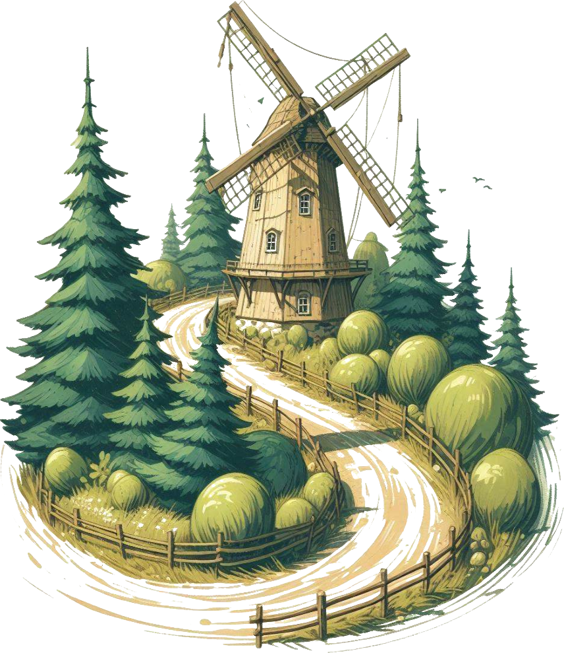

# Title Gradient 6Combats

You will have to control monsters in combats. The book will tell you how to run each monster when the time comes.

Read the following guidelines, but don’t overthink them. They will come in handy later.

## Running Combats

When running combats, try to spread the enemies as evenly as possible on the players (e.g. if you have 4 enemies and 4 players, each enemy should attack a different player). Dying in the first round is no fun!

…unless players want to spread the damage differently (e.g. if the knight wants to front-line and take the damage instead of the mage in the back).

## Battle Maps

Each combat encounter comes with a battle map, which you can find in the Appendix. If you’re playing online, you can use the exact map. If you’re playing on a table with pen and paper, you can draw a sketch of what the battle map looks like.

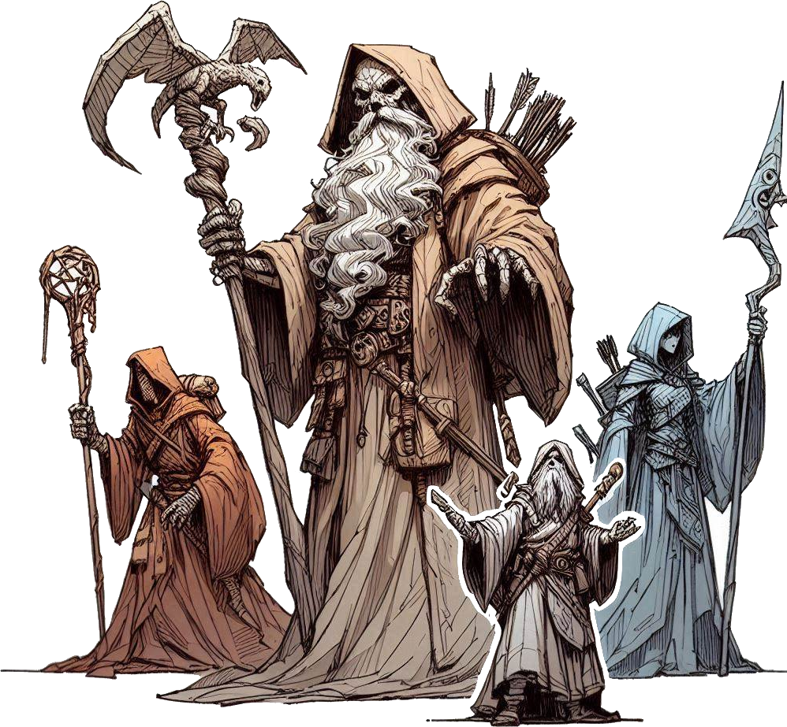You can skip some of the details when drawing (e.g. trees, rocks, etc) unless it specifically says that thing is important to the map.The map annotations are self-explanatory. Diamonds represent player or allied Units (creatures). Blue for players, green for allies, yellow for neutral. Circles represent enemies. Red for hostile, orange for possibly hostile.

## Important: Knowledge is Power

Player knowledge is key to them succeeding in combat. When a monster uses a special Ability, tell the players the exact effect of the Ability.

When the players hit a monster and it has a weakness or a resistance, let them know that their hit was not very effective (or that it was).

You may keep Monster numbers hidden, but make sure you track them (e.g. Health, Stats, etc).

If ever a player wants to know more about a monster, let them roll an Intelligence Check.

Every GM does narrates, tracks and manages combat differently - feel free to use your intuition on how to run monsters, but keep it simple and follow the rules.

# Title Gradient 6Locations & Sections

The story begins as soon as all the players are ready and have their characters finished.

Fire on Mount Hyhelm sees the players being called for a job in a town at the base of Mount Hyhelm to investigate a strange light that can be seen on the mountain at night.

The players will talk to the mayor of the town and to the townspeople, and set off to climb mount Hyhelm. They will find strange tracks, dead bodies of lost adventurers, fight moths and spirits, and finally, confront the culprit: a part-moth woman who was feeding on lost adventurers.

When you want to present the idea of

Whispervale to your players, read the following

out loud:



*Hyhelm - mountain as old the land itself, whose*

*peak has curiously not yet been explored. Plenty*

*of adventurers have tried reaching it, yet none*

*of them has ever been seen again.*

*Lately, a strange light has appeared on the*

*mountaintop, and it seems to be correlated to*

*certain unusual happenings around the town at*

*the mountain’s base. And you were the ones*

*called to investigate and find out what is*

*troubling Mount Hyhelm.*

*You will be playing the roles of fresh adventurers*

*hiking to the town of Farwood and climbing*

*mount Hyhelm.*

*You will talk to various characters, battle*

*monsters, solve puzzles and piece together clues*

*to solve the overarching mystery of Hyhelm.*

*So ready your sword, find your notes and your*

*map markers, plan out accordingly, and immerse*

*yourselves in the story of Mount Hyhelm.*

You can give the players the extra information that they will play Level 1 characters. There are (hopefully) no elements that would make the players uncomfortable:

There is no depicted gore or disturbing visual imagery in the book, not shown, nor told. There are no disturbing visuals and no topics that would be considered “taboo” in the real society.

However, the story can be gloomy, and contain potentially unsettling monsters or unusually looking people.

It can be noteworthy that this adventure is quite “railroady” (linear), as it is intended for beginners.

## Player Backstories

Player backstories won’t really matter, unless you choose to improvise them into the story, though that can be difficult. Tell them to come up with adventurer characters. with simple backgrounds, that would accept to be paid to investigate a mystery by climbing a mountain.

The story assumes the characters did not know each-other previous to their meeting in the first chapter.

## Story Explained

A few months ago, a strange light appeared on top of Mount Hyhelm. Several people went to investigate, but none returned.

In the settlement of Farwood, the mayor’s wife, Rilda, decided to investigate herself, as she was an experienced hiker. Her husband, the mayor, refused to let her, so she snuck out during the night.

Most people (men) die on their way up due to the traps of the hermit, Hail. The hermit let her pass because she was a woman and dying of an incurable disease - she was a suitable host for the *light* on the mountain.

The hermit took Rilda to the *light*, who was actually a *possessing* *fiend* looking for a suitable host. Rilda was such a host. The light fiend turned her into a part-moth being. The fiend has the ability to attract people to it, like moths to a flame, and devour them.

The players will have to kill Rilda (the light fiend), and Hail the hermit (optionally).

# Title Gradient 6Rules To Remember

Follow the script of the adventure - it will tell you exactly all you need to do and say. No need to improvise, unless you want to.

Players will not Level Up, nor will they regain full resources until the end of the story (there is no such thing as a *Long Rest*).

If a player falls to 0 Health, they become Fallen and must skip their turn. When Healed, they get back up with Exhaustion (halved Actions and Speed). When a monster reaches 0 Health, it dies.

For all intents and purposes, players can’t die this adventure, unless they do something really stupid. No combat should be hard enough to have players wipe.

## What Players Should Know

From the start, the players should know the following:



*Before we begin, here are some things you should*

*know: you should track your own Health, Mana and*

*resources, since they will keep changing.*

*It will also be very useful to take notes, as there*

*could be information you need for later.*

*You will be fighting monsters, solving puzzles and*

*talking to various characters throughout the*

*adventure. There will be a few combats, a decent*

*amount of roleplay, and puzzles, taking roughly*

*33% of the entire session each. The story is rather*

*linear, but there will be choices to make.*

*Note that every non-player character may like or*

*dislike you, and everything you say to them will*

*influence how they react, what they do and how*

*much they trust you.*

*As an ethical guideline, try not to split the party,*

*interrupt people while talking, and remember that*

*the Game Master always has the last word.*

*Most importantly, have fun and make sure everyone*

*else is having fun, too!*



# Title Gradient 6Road to Farwood



*Just a while ago, you gathered with your companions*

*along a winding path through a pine forest, steadily*

*gaining altitude as you get ever closer to the*

*mountainside. It is a clear winter day, the sun*

*illuminating patches of snow nestled among the*

*green fir trees.*

*On the distant horizon, a magnificent snow-capped*

*peak reaches towards the clouds behind the woods.*

*You are all traveling to the mountainside town of*

*Farwood, where you were summoned via a job*

*poster for a mission atop the very peaks of the*

*mountain before you - Mount Hyhelm.*

*On your travel thus far, you’ve had ample time to*

*bond, and trust each other that you are a team on*

*the same mission, watching each other’s back.*

*[As GM] One by one, describe your characters’ name,*

*race, class and personality.*

Wait for the players to describe their character, each (you can go in a circle), then continue.



*As you press onward up the mountain trail, the path*

*narrows, requiring caution to avoid slipping down*

*the lightly snowy cliff to the side.*

*Your journey comes to an abrupt halt as you*

*encounter an obstacle: a thick fir tree lies fallen*

*across the road, blocking your path forward. To your*

*left, a steep cliff descends several meters, while to*

*your right, a sheer rock wall rises.*

*Working together to overcome this obstacle, what*

*do you do?*

## While they are thinking…

Let players come up with a solution.

If something they do requires any amount of effort, they will need to roll a Check - a d12 (12-sided die) roll, to which the player can add their Stat. If a Check requires physical strength, they can add Might. If it requires mental effort, they can add Intelligence. And so on.

A medium-difficulty Check usually requires the final result to be at least 10. Feel free to alter this number by -5 or +5 (or other numbers) depending on how hard you think the Check is. Note that rolling a 12 counts as a 15! Players might also have Skills (see below).

For this challenge, there are no drastic consequences to failure, but failing a Check usually means they can’t

attempt it again.

For example, jumping over the tree is not very hard (roll at least 10 on a Dexterity Check). Lifting the tree is more difficult, and will require a combined total of 20 from the sum of multiple people.

Whenever you reach this point, continue:



*If any of you has a Skill that you think will be useful*

*in this situation, let us know. They are written under*

*the Skills box on your character sheet.*

*Being Skilled in something means you can also add*

*+1 to your roll! If you are Skilled in Jumping, and*

*want to jump over the tree, you can add an extra*

*+1 to your roll!*

*This +1 comes from your character’s level, which is 1.*

*Whenever you feel like you have a Skill that would be*

*useful in a situation, make sure you say so!*

When the players manage to get past the tree, lightly narrate their success, and continue.

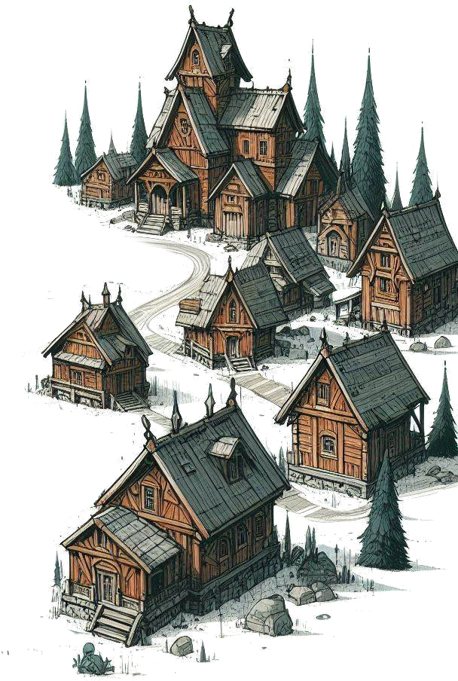

*Continuing along the winding path towards Farwood,*

*the daylight wanes, due to the winter’s early sunset.*

*As you press onward, it is slowly getting darker and*

*darker.*

*In this dark evening, you are met with a comforting*

*sight of wisps of smoke dancing on the horizon,*

*signaling your approach to civilization. The dirt path*

*beneath your feet transitions into cobblestone, and*

*stepping beyond the shroud of dense trees, the*

*silhouette of the town comes into view, beckoning*

*you closer with its promise of shelter and warmth.*

*You are now entering Farwood.*

*The village comes alive in the soft glow of torch lights,*

*from people roaming the streets looking to end their*

*day’s work. Spruce log homes, both small and large,*

*dot the roadside, lending the village its rustic charm,*

*filling the air with a smell of stew, fresh bread and a*

*hint of burning tobacco.*

*Moving forward along the cobblestone path, two*

*guards perched atop a snow-covered tree stump*

*watch your approach with keen gaze.*

*But soon, their gaze locks in a different direction: up.*

*Looking above you, toward the large mount Hyhelm,*

*you can see a faint, orange glow, up high on the very*

*peaks of the mountain.*

*You figure* ***that*** *is the far away mysterious light*

*you’ve been called to investigate.*

*It is nearing 7:00 in the evening. You are in the central*

*marketplace. The path forward leads to a large, town*

*hall-like-looking building, while the road to the left*

*seems to go toward a tavern.*

*What do you do?*

Players might go to any of the following:

* *Town hall (Hadden)*
* *Tavern (Chew)*
* *Guards & Marketplace*

When the players decide to go to any of these, flip to that location’s page.

# Gradient TopTitle Gradient 6Town Hall (Hadden)



*You journey onward toward the large building over*

*yonder, also made of dark wood, with a fine stone*

*base and a beautiful roof of a differently colored*

*wood.*

*You are greeted by a couple of guards, wearing a*

*green and red outfit, with a chain mail shirt and*

*capes made of thick hide. One of them is a human,*

*in his 40’s, and the other one is a grizzled dwarf,*

*each carrying an arming sword on their belt.*

*The human takes a few steps forward towards you,*

*and greets you:*

## Guard Edgar

From the start, the players should know the following:



*“Halt! Who does there?”*

*“What is your business with Mayor Hadden?”*

*[If it’s evening] “It is quite late, I don’t think Mayor*

*Hadden has time for you right now…” [the players*

*might be able to convince him to let them in; they*

*would need to roll a Charisma Check at least 10]*

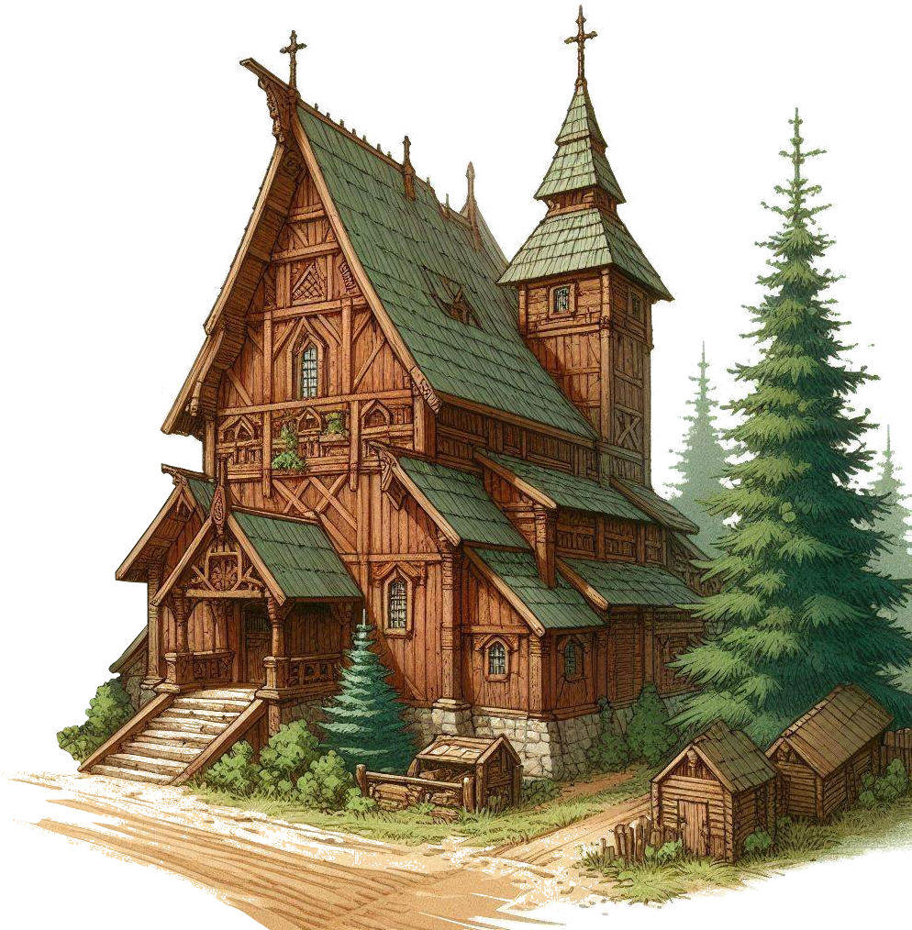*[If it’s not evening] “You’re in luck - there are no*

*other appointments at this time of day. We’ll take*

*you in.”*

*“If you wish to go inside, you’ll have to leave your*

*weapons here at the door.”*

*…The dwarf guard? Name’s Gorad. He is mute, he*

*doesn’t speak.*

*…Light on the mountain? Oh yeah, it’s been there*

*for a while. I think it’s dimmed lately. Maybe it’s*

*gonna extinguish soon…*

*…Called for a mission? Ah… good. Finally someone*

*to go up there and see what’s up. I would go myself,*

*but I’ve got a family and all… too risky for me, and*

*for my partner here Gorad.*



*The guards take you to a room, just inside the large*

*building. Knocking softly on the door, they receive a*

*faint “Yes?” response from inside. Guard Edgar*

*opens the spruce door, his boots dripping melting*

*snow on the gray fur carpets laid on the floor.*

*Inside the room, a cozy fireplace is lit, and on the*

*other side, a large desk with shelves over shelves of*

*documents set against the walls.*

*Sitting cross-armed on the edge of the dark wooden*

*desk, a figure stands no taller than 1.80 meters.*

*Though his height is greatly increased by an ornate*

*hat.*

*The man looks at you with piercing eyes, of a light*

*brown hue. You can identify no intense emotion on*

*the man’s face - his gray goatee and sideburns*

*would have given it away.*

*[If it is evening] “You have finally arrived. I couldn’t*

*have waited any longer. Welcome.” says Mayor*

*Hadden with a tired voice, and then addresses the*

*guard: “Close the door, would you? Thanks.”*

*[If it is not evening] Mayor Hadden looks a his*

*ticking clock on the wall. “You know I deliberately*

*did not take any appointments, at this exact time?*

*I was right. Not a minute late, nor early. Welcome!”*

*says Mayor Hadden with a tired voice, and then*

*addresses the guard: “Close the door, would you?*

*Thanks. Let’s talk.”*

## Gradient TopMayor Tom Hadden



*“Have you ever been to Farwood, friends? No? It is*

*both beautiful, and terrifying, especially at night.”*

*[If evening] [Mayor Hadden goes to the window and*

*points] “That thing. The light. Now that’s creeping*

*us all out.”*

*[If day] “Not sure you can see it properly at this time*

*of day, but… if you look closely… [Mayor Hadden*

*goes to the window] You can clearly see it. Up there.*

*The light. You’ll see it when it gets darker, I’m sure.”*

*“That light has been there for months. Nobody*

*managed to reach it. And several people have tried,*

*though none has returned.”*

*“Not long ago, the light was shining brighter. Lately,*

*it has dimmed. As if the light has quieted down, for*

*some reason…”*

*“Something else started to happen since the light*

*dimmed. People of Farwood have been disappearing.*

*A strange coincidence, do you reckon? Now, if the*

*two are correlated, I want to know why. And stop it.”*

*“I want you to go up the mountain. First and foremost,*

*find out who or what is messing with the people, and*

*deal with the problem. Second, I want to know what*

*the light is, and, if it’s dangerous, deal with it as well.”*

*“Here…” [Mayor Hadden throws you a bag from under*

*the desk] “300 gold upfront. 700 more when you’re*

*done. There is a road through the forest, leading up*

*the mountain. After a certain point, you will need to*

*hike. The road only goes so high. Make sure you buy*

*whatever supplies you think you will need, from the*

*Town’s marketplace.”*

When the players are done, they may go up the mountain, to the tavern, or to the marketplace.

## *Tom Hadden (Mayor Hadden.png)*

Base Suspicion: 10

Smart, tidy, but a bit smug.

Feel free to show the players a picture of *Mayor Hadden*.



*…****People who disappeared****? In the past few weeks, we*

*have had 3 men who were never seen again… and a*

*woman. We believe they all went up the mountain of*

*their own volition. Ask the townsfolk around Farwood or*

*in the tavern.*

*…****Their families****? I know some of them, yes. But you’re*

*better off asking around town, see if you can find their*

*friends and family. They’re busy people.*

*…****My wife, Rilda****?* ***[requires Check]*** *I haven’t told you this.*

*Perhaps I should have. I don’t know where she is. Up the*

*mountain, I hope you will at least find her body. it’s*

*where she went, alone, and we could not find her. I*

*apologize… it is hard to talk about it…*

*…****Rilda being sick****?* ***[requires Check]*** *She had a disease…*

*we tried clerics, and doctors, but it was futile. There is a*

*hermit up the mountain, into the occult arts. I expect she*

*went to see the hermit, looking for a cure. I disagreed…*

*what with the people going missing… she went at night,*

*when I was sleeping.*

# Title Gradient 6Tavern (Chew)



*The cobblestone path through Farwood takes you to*

*the western side of town, where a large, single-story*

*tavern spans the whole width of the street. Above it,*

*a worn, wood-carved sign reads “Boar’s Hoard”.*

*Stepping in through the creaking door, a single*

*colossal chamber unfolds, its high ceiling adorned*

*with hanging lanterns that cast a flickering glow*

*upon the patrons - some sleeping in hammocks, and*

*some having a bite to eat. Judging by the smell -*

*venison.*

*At the heart of this bustling establishment, a small,*

*wide figure clops around. His tusks gleam with pride,*

*and his brown fur smells of grapefruit liquor.*

*It is a boar-folk Bertle bartender, trying to reach the*

*opposite end of the tavern with several dirty plates*

*stacked one on top of another.*

If the players want to talk to him, feel free to have other people around join the conversation freely. Change the person speaking at will (most of the following dialogue lines can apply either to the bartender, or people around).



*“Ho there! Easy now, have a seat! Food? Drinks? Some*

*citrus for the ladies? What can I get you?”*

*“You talked to the mayor, huh? He can seem pretty*

*tough. Poor bastard’s never been the same since his*

*wife vanished, a few months back. He won’t talk about*

*it, no. But we all know barn well that’s the main reason*

*he hired you. To find his wife.”*

*“You know, there really is a hermit living up there, goes*

*by Hail. I expect Hail did some of that black magics.*

*Used to be a common-folk years ago! Nobody really*

*knows Hail, really. It’s all just rumors. But if you’re*

*looking for a troublemaker, that’s your lead.”*

*…****Mountain trail****? Oho, expect some 2, maybe even 3*

*days’ hike to the top. Better be well-prepared!*

*…****People who disappeared****? Ho, let’s see… A hunter -*

*Stok, went into the forest for game and never came*

*back. Had a dwarven rifle. We also have a missing*

*camper - he goes camping several times a year. There*

*was also an old elf pilgrim. Goes up to the shrine all*

*the time. This time, he did not show back down…*

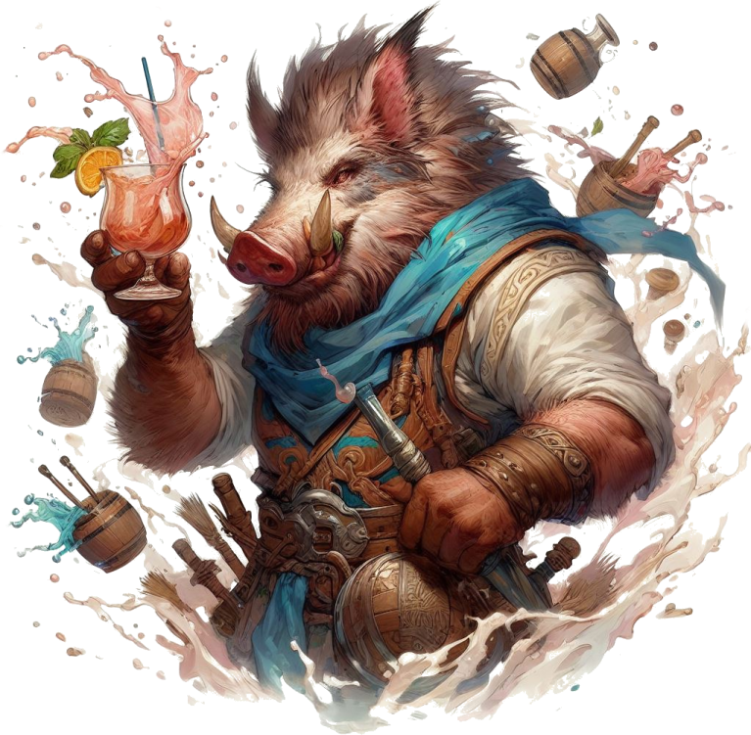

## *Gow “Chew” Boaris (Chew.png)*

**Base Suspicion**: 7

Very friendly and stocky. Loves a good smell.

Feel free to show the players a picture of *Chew*.

Rents rooms for **10g per night** (per person). Offers meals for **5g per mea**l, and **2g per drink**.



*…****The hunter, Stok?*** *Went to hunt moose, most likely, one*

*week ago. Fine dwarf. Just wants to provide for his*

*family.*

*…****The hiker, Triny****? A gnome hiker. Likes to find berries*

*and catch birds. Lived alone right here, in this tavern.*

*Made his coin off of his flute shows. Went missing 2 or*

*so weeks ago.*

*…****The pilgrim, Wonnen****? Old elf. Was the main cleric of*

*our town. He is what we call a “generic priest” - knows*

*all sorts of things about all sorts of religions and all. He*

*was reported missing just 2 days ago.*

*…****The light****? It’s been there for a year, give or take.*

*…****The light dimmed****? Ho, I never really noticed it. Yeah,*

*you’re right! I do believe it’s dimmer now! Huh…*

*…****Mayor’s wife****? Rilda was her name. Rumor has it she*

*went to investigate the light herself, but never came*

*back. This was some weeks ago, I think?*

*…****The hermit, Hail****? Wish I knew more. Lives past the*

*cleric’s shrine, up on the mountain.*

*…****People investigating the light****? There have been*

*attempts, over the year. None came back…*

# Title Gradient 6Marketplace

If players first went to the mayor or the tavern for the day, the marketplace is closed. They must return tomorrow to buy things.

They may still ask people around for clues.



*At the heart of Farwood, a small town center forms*

*around an old stone water well, makeshift tents*

*surrounding the area. It is not bustling.*

*[If evening] At this hour, most of the people of*

*Farwood have packed up and gone back to their*

*homes, and the ones who haven’t left already are*

*doing this very moment.*

*[If day] The marketplace is open, plenty of shops set*

*up selling food, tools, and maybe even a magic item*

*or two.*

## Prices & Items Available

When they want to buy items, show them the **Prices** sheet from the appendix. That’s all the marketplace has to offer in Farwood.

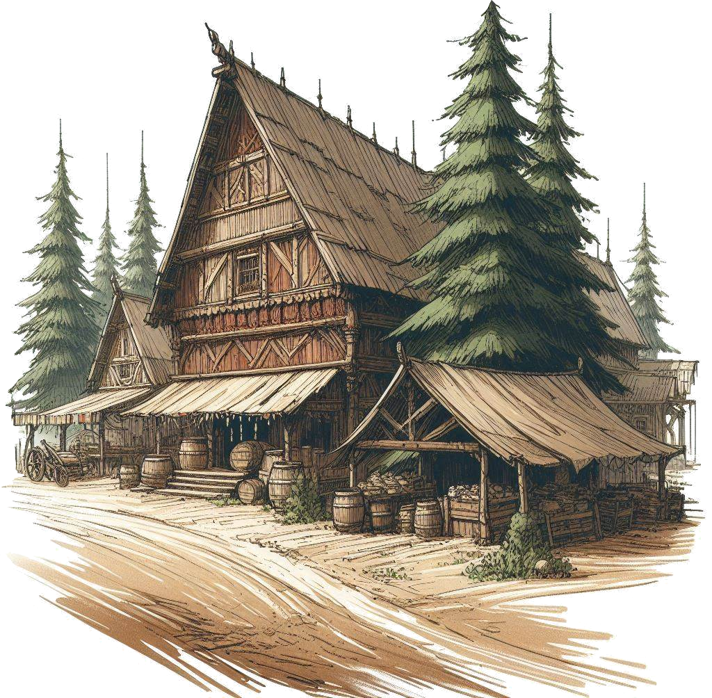If they ask, players may get a discount equal to their 5 x Charisma.

## Commonfolk Dialogue

These dialogue lines apply for sellers, random folk,

etc. Feel free to improvise names and personalities.



*...****The mountain****? It’s our natural beauty! Make sure*

*you are well equipped for camping and the cold!*

*..****.People who disappeared****? Well we’ve got the*

*mayor’s wife, Rilda, Wonnen the generic cleric, Stok*

*the dwarven hunter, Triny the gnome, and a bunch*

*of other adventurers, months back.*

*...****The hunter, Stok****? Traded meat and hides. Went*

*hunting one day, and poof! Never seen again! Now*

*we’re stuck eating carrots and lettuce!*

*...****The pilgrim, Wonnen****? Well, holy damn, we miss*

*him gravely! There’s a shrine up in the mountains, he*

*used to go pray. If you go out there, do look for him!*

*The shrine is right on the trail through the woods, you*

*can’t miss it!*

*...****The light****? Well, lo and behold! It’s our town’s*

*touristic attraction! Reckon we can make some coin off*

*of it. Been there all year! Some say it’s a fiend or a*

*demon or so. I don’t know, it helps me fall asleep at night.*

*…****The light dimmed****? Yeah, it did! A few weeks ago! Hope*

*it doesn’t extinguish itself too soon! I quite like it!*

*…****Mayor’s wife, Rilda****? Now that woman was something*

*else! A beauty worth no one’s eyes! Rumor has it she was*

*slowly dying of a disease. Who knows if it’s true. But my*

*guys, let me tell you, she was drawn to that light like a*

*moth to the flame! Curiosity killed the cat, I say!*

*…****The hermit, Hail****? She’s freaking insane! Into the*

*occult and all. Summons demons, breathes fire, and all…*

*They say she was a villager of Farwood, back in the day.*

*No villager I know that I’d let summon demons! I tell ya!*

*Wanna find her? Head up the mountain, past the shrine.*

*She’s more than a day’s hike, though. I’d definitely start*

*questioning her! I think she left the village right about*

*when the light first appeared!*

*…****People investigating the light****? People come and go.*

*Now that I think about it… other than the mayor’s wife*

*and that hermit, don’t think I’ve ever seen a woman go*

*up there. Just men.*

*…****Dangerous****? As long as we didn’t go too far up the*

*mountain, we used to be safe here! Seems nowadays*

*you can’t even go for a stroll!*

# Title Gradient 6Base of the Mountain

*As you ascend the mountain road, the chill in the air*

*grows sharper. Snow starts to blanket the landscape,*

*the atmosphere well set by the occasional sight of a*

*deer and other wildlife. The road goes up, with a small*

*clearing forming on your right.*

*The crisp scent of pine invigorates your senses, and,*

*while you notice traces of past human travelers, they*

*appear normal, without any cause of concern. No*

*suspicious sight yet. By this point, you’ve been walking*

*for several hours.*

*[As GM] The person furthers in the front - make a*

*Sense Check, maybe you can see something useful.*

*[If at least 8] Dried on the bark of a tree, you spot a*

*red smear. You approach to investigate further, and*

*notice red marks going off-trail toward the clearing*

*on your right.*

*[if not] You believe there could be a bear, or a wolf,*

*nearby, so you tread carefully through the snow. It*

*should not pose a threat to your party.*

*[Continuing] You still have a solid few hours of*

*daylight before you would have to camp the night.*

## If they go to the clearing…

*Headed to the clearing, you spot more and more*

*such spots on the trees.*

*[If a player wants to find out more, they must roll a*

*Sense Check at least 10] It looks as if someone was*

*running away from something. You spot very old boot*

*marks underneath the snow, dwarven sized.*

*[Continuing] About 100 meters in, something shines*

*in the snow. [If players go to investigate] It seems to*

*be a hunting gun [give the players Stok’s Gun].*

*[Continuing] Over yonder, you spot a body, fully*

*covered in snow.*

*[If players go closer to investigate] You try to wipe the*

*snow off of the body, but touching it makes it blow in*

*all directions, like a puff of smoke. This isn’t snow that*

*was covering the body. It’s a form of soft, white fur.*

*You recognize that this is the body of a dwarf.*

*[Sense Check -- at least 5] The dwarf’s body seems*

*partially eaten, mostly by small bite marks.*

*[At least 8] You can see a lot of small holes in his*

*clothing.*

*[At least 11] There are no other trails except some*

*small holes in the dirt, under the snow, no thicker than*

*10 centimeters in diameter, as if someone had*

*inserted stakes or spikes in the dirt, and removed them*

*afterward.*

*[At least 13] There is a subtle, sticky white dust also*

*stuck to the trees around the area. Simply inhaling it*

*starts to make you feel tired.*

*[Continuing] You are able to scavenge what you can from*

*the dead dwarf’s backpack and pockets.*

## Dwarf’s Backpack

They find a **Heavy Gun** (from the Appendix) with 5 shots worth of gunpowder, apparel worth 103 gold, a portable tent and a backpack.

## Continuing…

*You continue up the road, spending the next hour*

*hiking along the road. As you ascend, it gets*

*progressively more difficult to climb - steeper and*

*less paved.*

*Daylight is now starting to wane, but you soon spot*

*a silhouette up in the distance, of what seems to be*

*a stone obelisk.*

*Someone make a Sense Check.*

*[If rolled at least 12] Up in a tree, not far from your*

*position, you see a small wooden effigy. A pagan sign*

*in the shape of an infinity sign made of sticks and tied*

*with rope.*

*[Let the players find a way to get it down if they want]*

*[If they do, give them the Effigy from the appendix]*

*[Otherwise] The obelisk in the distance is unmoving.*

*[Continuing] As you approach, you see some holy*

*runes on the obelisk, marking that this is likely the*

*a religious shrine, used for prayers by pilgrims.*

*That is not the only thing you notice.*

*From behind the tree appears a large floating animal.*

*It looks like white butterfly, or a giant moth, its silvery*

*wings as imposing as its huge fangs.*

*Another one appears from around the cliff, flying*

*toward you with intent.*

*You are being attacked by them! Roll initiative!*

# Title Gradient 6Moths Combat

The map is in the appendix (*Battle Map Shrine.png*).

Players are coming from the bottom, going to the top.

Put one player near the shrine (top-right-center).

Put the rest of the players wherever appropriate, depending on where they said they would be (or put them randomly, in the vicinity of the player near the shrine).

Spread the the Hawkmoths evenly, so that no one player is overwhelmed.

 *[As GM] Everyone roll a 12-sided die and add your*

*Initiative number to that roll.*

*You will take your turns in the order of your turns.*

*Higher Initiative goes earlier, lower goes later.*

*Monsters have fixed initiative, and don’t roll.*

*For example, these moths have an initiative of 8.*

*The spectral serpent has an initiative of 4. If you*

*rolled above or equal to 8, you go before them all.*

You (the Game Master) need to play each monster accordingly.

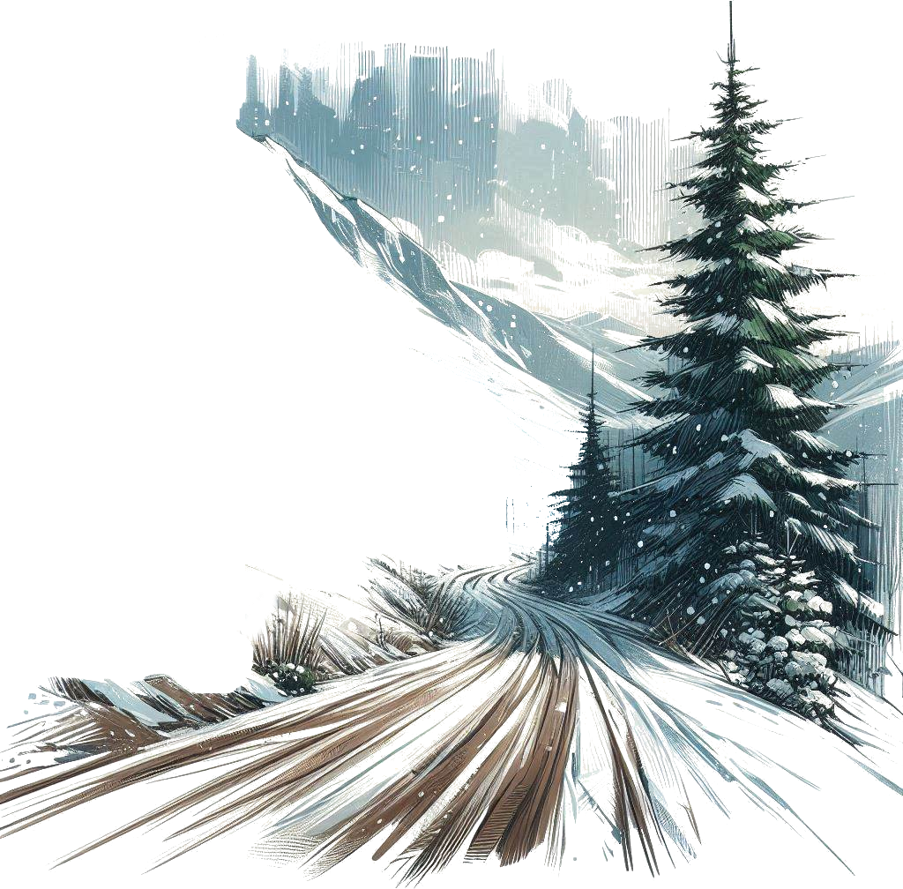Each monster, on its turn, has 1 Action and can move. Monsters with the same initiative can take their turns in any order.

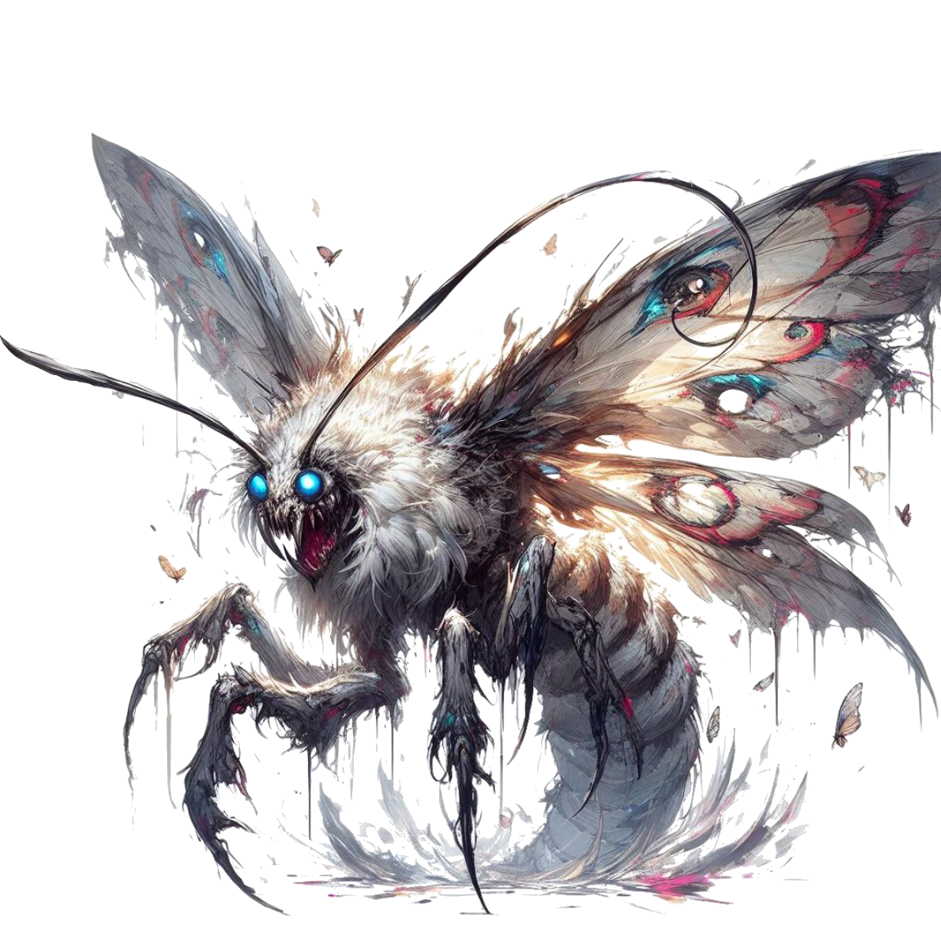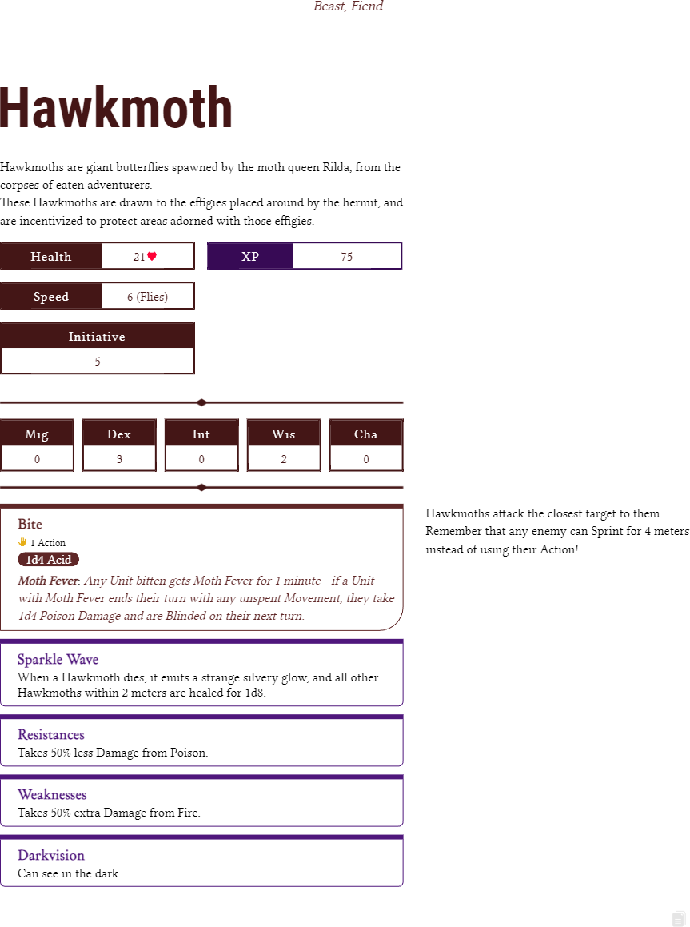

## Gradient TopWhen combat is over

*As the final moth takes its last breath, you spot at the*

*corner of your sight a figure watching over you from*

*ahead, which quickly takes off and disappears into the*

*white landscape contrasting with the late day’s*

*darkening sky.*

*Looking up, you can see you are closer to the*

*mysterious light, yet not close enough to discern any*

*of its qualities, other than its yellow-ish color.*

*It will soon be night time.*

## Loot

The moths didn’t drop much, except for 1d100 grams of Strange Dust, per each Moth.

Once 100 grams of dust are gathered, they can be sprinkled to inflict Blindness

See **Strange Dust (100g)** in the appendix.

## Night on the mountain

*As the night draws closer, it is also progressively*

*getting colder. The path goes forward, through*

*rocky passages and snowy clearings.*

*What do you do?*

The mountain is very cold at night.

After a bit of time, ask every player to make a Might Check to see how well they resist the cold.

If they get at least 15, they’re fine.

Otherwise, they will take 4 Damage (spread among the next 4 hours).

If a player has taken proper measures to resist the cold (e.g. buying thick clothes), secretly give them a +5.

Improvised clothing will give them +2.

Fire will give +2.

Any other measure may give them +2.

## If they make a fire (or torches)

*You notice strange small moths gathering around the*

*fire, flying around it. It is no swarm, but their wing*

*flaps are enough to block part of the heat and light*

*emanating from your flame.*

## Night’s end

The night passes without any other events.

# Title Gradient 6Mountain Path

*The path up ahead is clear, and you take to it and*

*carry on your hike.*

*Daytime on mount Hyhelm is more forgiving than the*

*cold night.*

*As you traverse the snowy mountain path, you soon*

*reach a sort of crossroads: the path splits into two*

*diverging routes. The left side leads towards a distant,*

*weathered rope bridge you can see from a distance.*

*You spot human tracks leading that way.*

*Alternatively, the path to the right winds along the*

*mountainside, its rocky terrain hinting at a more*

*challenging route.*

*What do you do?*

Broken Bridge



*Continuing along the left side of the winding mountain*

*path, you navigate through snow covered terrain until*

*you reach an abrupt halt. Before you lies a 5-meter*

*wide chasm, falling down all the way to the depths*

*of the mountain. There appears to be no way round it,*

*and the rope bridge you glimpsed earlier from afar was*

*merely a scaffolding.*

*Unfortunately, the majority of the bridge is collapsed,*

*now hanging down from your side of the cliff.*

*What do you do?*

Depending how difficult what the players want to do is, make them make Checks (5, 10, 15 or even 20 difficulty).

Jumping the chasm requires a 15.

*Remember that a natural 12 counts as a 15!*

There are several ways to cross the chasm; let players improvise.

Avoid having the players fall down the chasm to their death (e.g. save them if that happens).

## Continuing

*Having fully traversed the chasm and rounded the*

*corner on the road, your attention is drawn to a pair*

*of legs that can be seen from the roadside. A strange*

*rumbling noise emanates from that direction.*

*As you cautiously approach, you see blood splatters*

*on the ground.*

*Drawing nearer, you discern another horrifying figure*

*hunched over the corpse.*

*What you are looking at is no human, nor beast. It’s a*

*grotesque amalgamation of a woman and a moth, its*

*wings spanning several meters, eyes glowing like red*

*fires, and razor-sharp claws on its hands.*

*The moment your eyes meet, it locks its gaze on you,*

*alert to your presence.*

## If players want to fight or talk

*The figure seems confused at your gestures, and quickly*

*spans its wings. With a couple of flutters, it flies away up*

*the mountain, and out of sight.*

## Otherwise, or if players **really** want to fight

The player who was most eager to fight can take a turn, without necessarily drawing a map. Any Damage they deal to Rilda is subtracted from her Health in the final boss battle.

Rilda will teleport away immediately after the player taking its turn.

## Corpse in the snow

*Drawing closer to the fallen figure in the snow, you*

*uncover the half eaten remains of an elderly elf man.*

*His attire suggests he was a cleric, adorned with*

*symbols of several faiths. Remarkably, his supply*

*pouch is intact, and within it, you discover a small*

*journal containing hastily scribbled notes.*

Inside the pouch, players find 93 gold, Wonnen’s Notes and a Ring of Health (from the Appendix).

## Road to the hermit

*With only one path ahead, you determine to press*

*onward and up the mountain, convinced you’ve seen*

*all there is to see here. You continue your ascent,*

*getting ever closer to the light on top.*

*As you were trekking, it began to snow.*

*However, you’ve been spotting light clues of someone*

*living about.*

*Suddenly, you hear a grunt coming from a sheltered*

*sideroad nearby. As you approach, you notice a…*

*person. Though, whoever this is seems to have lost*

*some of its humanity.*

*It is an elven woman, dressed entirely in white-tan*

*silk clothes, partially eaten by the moths flying all*

*around her.*

Continue to the **Hermit**.

Rocky Pass



*Venturing along the right side of the path, the terrain*

*grows increasingly challenging, with steep descends,*

*jagged rocks, and frost-covered cliffs.*

*The rock formations eventually turn into the entrance*

*to a cavern.*

*As you cautiously step inside, you are enveloped by its*

*gloom and cold. Gradually, your eyes adapt to the dim*

*light, and you spot an unsettling sight to the side: a*

*peculiar organic structure, resembling a cocoon.*

*However, as your gaze shifts, a sense of foreboding*

*washes over you when you realize the entire cavern is*

*filled with cold moth cocoons, coating every inch of*

*the ceiling and walls.*

*You just stumbled upon a nest.*

*Directly ahead stands a steep cliff rock ascending*

*around 4.5 meters, almost completely vertically. It*

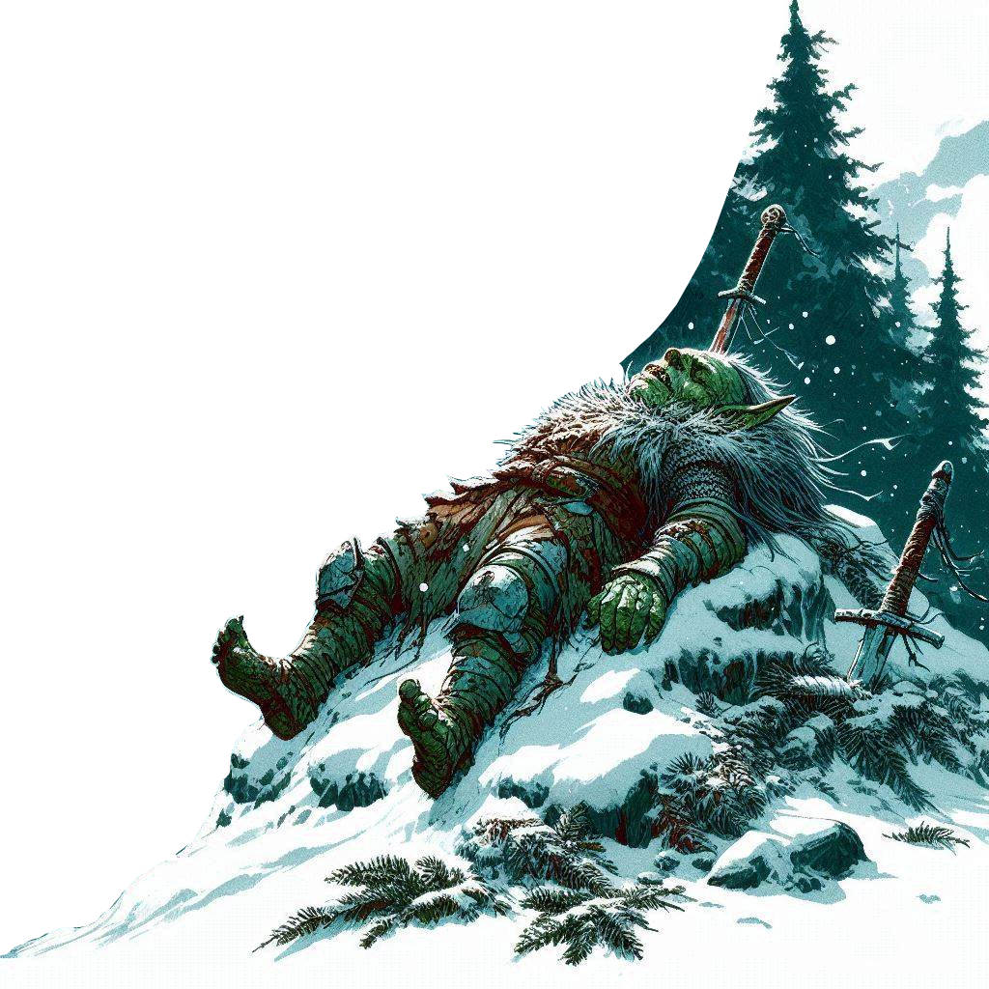*appears the only route forward among the incubating*

*giant moths.*

*What do you do?*

Depending how difficult what the players want to do is, make them make Checks (5, 10, 15 or even 20 difficulty).

Running against the cliff and jumping requires a 15 to climb.

*Remember that a natural 12 counts as a 15!*

There are several ways to climb the wall; let players improvise.

However, failing **any** physical check in here with a 5 or below, causes a cocoon to explode in a toxic fume damaging the player for 2 unavoidable Poison Damage.

## Continuing

*Having successfully scaled the cliff, you pause to catch*

*your breath, taking in the cavern’s continuation for*

*several dozen meters. Across the expanse, you discern*

*a small figure slumped against the wall, clearly dead.*

*Nearby, another individual is crouched beside the body,*

*murmuring incomprehensibly as they investigate the*

*body.*

*It is an elven woman, dressed entirely in white-tan*

*silk clothes, partially eaten by the moths flying all*

*around her. She is standing between you and the way*

*up, through a vast ascent of sharp rocks and cliffs.*

Continue to the **Hermit**.

Players may want to continue their journey - if they do, go to **Sharp Rock Ascent**.

## Body Loot

If players investigate the body, it appears to be the corpse of a poor, ragged gnome.

On his body, they find 6 gold, an old violin worth 90 gold and **Dead Gnome Note** from the Appendix.

If they check underneath his right shoe’s sole, they find a **Ring of Recovery** from the Appendix.

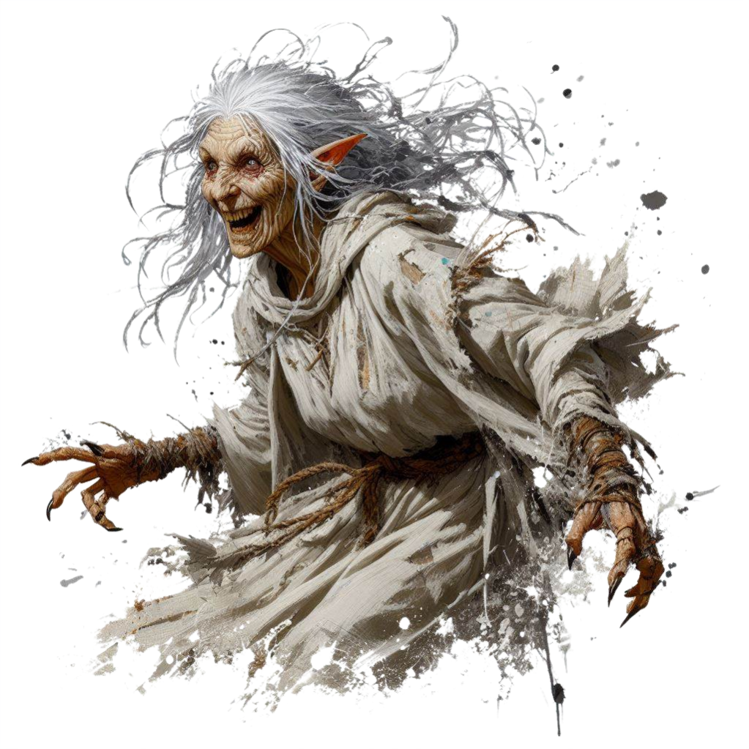Hermit



*“Begone! The light is not for you!”*

*“What is it you seek!? Turn back! The light does not*

*want you here! It has already dimmed, and you’ll just*

*make it worse!”*

*...****Occult magic****?* ***Summoning demons****? No, no, no, no!*

*I just protect the light with the moths it gave me! It*

*wishes nothing from you! But was not worthy enough.*

*I was too old…*

*...****The light****? Oh, it is alive! And* ***I*** *was first to find it! It*

*should be all mine! First female of the light! For it slays*

*any man who gets close!*

*...****Disappearing*** *or* ***dead people****? [requires Check] Ah!*

*The favored host of the light. The ones in the old days*

*were foolish men, curious or looking for treasure. The*

*light had no need for them… but the light attracts all*

*equally… as it attracted you, no? Like moths to the*

*flame… And so, the light simply kills any man*

*approaching.*

*The rest, lately - all eaten and killed by the light’s new*

*host: Rilda.*

*...****Mayor’s wife, Rilda?*** *Yes… she was the perfect host*

*for the light. Rilda, wife of mayor! The light looked for*

*a suitable host, who still had the power to breed, and*

*whose life depended on it. The light saved her, and*

*offered her a different way to live! Made her so, so*

*beautiful… and I was too old, and my faith was tested*

*and I failed… but now I hope… maybe there is hope.*

*Maybe the light will share its power with me, alas…*

*...****Moths****? From the blood of those who dared venture*

*too far rose moths, small and large. It is the will of the*

*light to spread its children among the world. The more,*

*the better! [requires Check] And Rilda is the chosen*

*moth queen. An agreement from both, nevertheless.*

*She must feel powerful! But how her soul feels, I can*

*only guess.*

*...****Get to the ligh****t? [requires Check] Of course you*

*want to get to it! Everyone does! But not many deserve*

*it! I did not deserve it… there is a hidden cave passing, I*

*can show, but you will only find your doom! Feed for*

*the winged children. Follow me!*

***…Effigies?*** *[requires Check]**They merely instruct the*

*moths to protect the area… among other things. You*

*may keep one, for protection.*

***…The corpse****? Never seen him! I just scavenge! Not*

*much to use on him. You can take his belongings.*

## *Hail (Hail.png)*

**Base Suspicion**: 10

Somewhat mad. Pendulates between friendly and very mean.

Does not remember her real name, nor her time in the village.

Can only cast small utility magic (Magic Tricks), but has no offensive spells.

She will not fight - she would rather run away.

On her, she is only carrying a concealed **Scroll of Frostbite** (from the Appendix).

## Hail’s Hideout Loot

If players got to Hail from the broken bridge, they can find some items in the hideout.

Hail will not willingly give any items, but can easily be intimidated or persuaded to share [requires Check].

They can find a **Blowgun** (from the Appendix) with 5 darts, 35 gold, a blanket and food for 3 days (raw peas).

With a Check at least 15, they can find a **Box of Peas** (from the Appendix).

Sharp Rock Ascent



*You embark on your ascent, scaling the rocky terrain*

*amidst the icy grip of the mountain’s peak. The climb*

*tests your mettle, each step made difficult by the*

*biting cold. Yet, fueled by the fervor to see the light*

*with your own eyes, you press on, hoping to reach the*

*next and final plateau of the mountain soon, as you*

*are not far from the summit.*

*[As GM] Everyone - roll a Check for climbing, with any*

*Stat you wish, as long as you can explain your*

*approach.*

Everyone rolling at least 10 will climb perfectly.

Everyone rolling 5 to 9 will take 1d4 Damage.

Everyone rolling 4 or less will take 1d6 Damage and be Slowed for the first round of the next combat.



*[at least 10] Climbing the mountain thus far has made*

*you prepared for the climb, and will manage to make*

*it through the rocky terrain safely.*

*[5 to 9] Pulling yourself up, you will manage to reach*

*the top plateau in decent condition, suffering only*

*a few small scrapes and bruises. You take 1d4*

*Damage.*

*[4 or less] This climb is one of the most difficult ones*

*you have ever done, and leaves you with a lightly*

*sprained ankle. You take 1d6 Damage and, in the next*

*combat, you will start as Slowed (which is -2 Speed).*

*Sweating and tired, you eventually step foot on the*

*final rock of your climb. It leads you to a serene,*

*snow-covered mountaintop, where the air is so thin*

*that you can touch the clouds. A fine mist, created by*

*the interplay of clouds and falling snow obscures your*

*vision as you look down toward Mount Hyhelm’s base.*

*The village’s lights are now just distant speckles, barely*

*visible from up here.*

*As you look up, not far, you see the light. A strange,*

*shrouded phenomenon of yellow-orange light, casting*

*its radiance across the snowy landscape of the*

*mountain top, almost like an artificial sun.*

*Just a little more trekking through the snow, and you*

*will reach your destination, putting and end to the*

*disappearances, and solving this mystery once and for*

*all. You are now on the peak of Mount Hyhelm.*

Stony Stairs



*The hermit woman hastily sets off in a stumbling hurry.*

*Leading you through the desolate landscape of dead*

*shrubbery, rocky outcrops and snow-covered hilltops,*

*she reveals a path hidden in plain sight among the*

*stony cliffs. The path appears man-made, resembling*

*a long, rugged staircase, ascending to the mountain’s*

*final plateau.*

*“Take the stairs.” she says. “They will lead you to the*

*light you so desperately want to see. It is where the*

*moth queen has her nest. I shall remain. My legs are*

*frail now.”*

*Knowing the mountain’s terrain, the journey will soon*

*transition to a smoother passage once you finish*

*climbing the stairs.*

*You start climbing. As you get higher and higher, your*

*world below shrinks into insignificance, replaced by the*

*powerful source of warm light you’re headed towards.*

*Time passes quickly. Sweating and tired, you eventually*

*step foot on the final stair. It leads you to a serene,*

*snow-covered mountaintop, where the air is so thin from*

*the altitude that you can touch the clouds. A fine mist,*

*created by the interplay of clouds and falling snow*

*obscures your vision as you look down toward Mount*

*Hyhelm’s base. The village’s lights are now just distant*

*speckles, barely visible.*

*As you look up, not far, you see the light. A strange,*

*shrouded phenomenon of yellow-orange light, casting*

*its radiance across the snowy landscape of the mountain*

*top, almost like an artificial sun.*

*Just a little more trekking through the snow, and you will*

*reach your destination, putting and end to the*

*disappearances, and solving this mystery once and for all.*

*You are now on the peak of Mount Hyhelm.*

Sharp Rock Ascent



*You stride across the snowy plateau, the clouds and*

*blizzard swirling around you as you head towards the*

*light. Despite the wintry conditions, an unusual air*

*penetrates the air. Step by step, you draw closer to*

*the nest of the moth queen, Rilda.*

*As you draw nearer, the blizzard intensifies. It is at this*

*moment you realize something peculiar - the blizzard*

*isn’t composed of icy snowflakes, but rather, it’s a*

*colossal swarm of small moths flying around you in a*

*foreboding dance.*

*You sense it - danger is close.*

*Before you, just a mere dozen meters away, lies the*

*elusive light that has captivated everyone’s attention*

*for so long. It stands before you now - a luminous orb,*

*its brilliance partly veiled by the swarm of white*

*moths. it emits a shapeless, radiant yellow glow, its*

*center pulsating with a strange energy. As you gaze*

*upon it, you notice something: it looks as if the light is*

*standing on a pedestal, or has a trunk like a tree of*

*sorts.*

*You want to take a better look, but as you do, amidst*

*the mass of moths, a silhouette forms from the fog*

*and takes shape - a surreal fusion of a woman and a*

*moth. Claws resembling razor-sharp daggers and*

*silvery wings spanning several meters, the creature*

*emerges from the fluttering swarm.*

*It speaks with a grotesque, inhumane voice:*

*“Behold, my saviour, and my curse monger”.*

*[As GM] Roll initiative.*

## Combat

Put Rilda on the center of the map Rilda Fight A.

Put the players a few meters south of Rilda, where appropriate.

Players will fight Rilda and The Light.



*[As GM] You are about to fight Rilda and The Light.*

*Rilda is an EPIC monster, meaning she takes 2 turns*

*instead of just 1, one right after the other.*

*All Stuns and similar effects will apply only to her first*

*turn every round.*

*Be ready!*

Once The Light begins its turn, the map will change to Rilda Fight B, and read the following passage:



*The land beneath you starts to shake, as if the earth itself*

*is being pulled apart in opposite directions.*

*You manage to hold your position on the plateau while it*

*extends on both sides, and the snow is shoved away.*

*Looking down, you now understand that the earth*

*underneath you is not part of the mountain - it is alive.*

*You are standing on the back of a gargantuan moth-like*

*creature, with a luminous lure on its head.*

## Rilda Dialogue

Rilda may talk to the players while fighting.



*”You are witnessing the entity that saved me, and at*

*the same time, cursed me with this form. I am no*

*longer myself. I am not Rilda. I am part of the swarm.”*

*“The light controls the swarm, and so does it control*

*me. It does not speak. It merely… communicates.”*

*“I willingly gave myself to it… the light saved me from*

*my deadly illness, and in return, it wished me to hunt*

*and help it spread its brood - moths from spilled blood.”*

*“It chose me, and only me… for it claimed my body had*

*the property of producing live cells at an abnormal rate.”*

***…Mayor Hadden****? He was my husband… and the light*

*was jealous. The light wanted no other male figure in*

*my life, other than it.*

*[When The Light starts its turn] “And only a woman could*

*become a queen. But every queen, needed a king. Behold!*

*The king of the swarm!”*

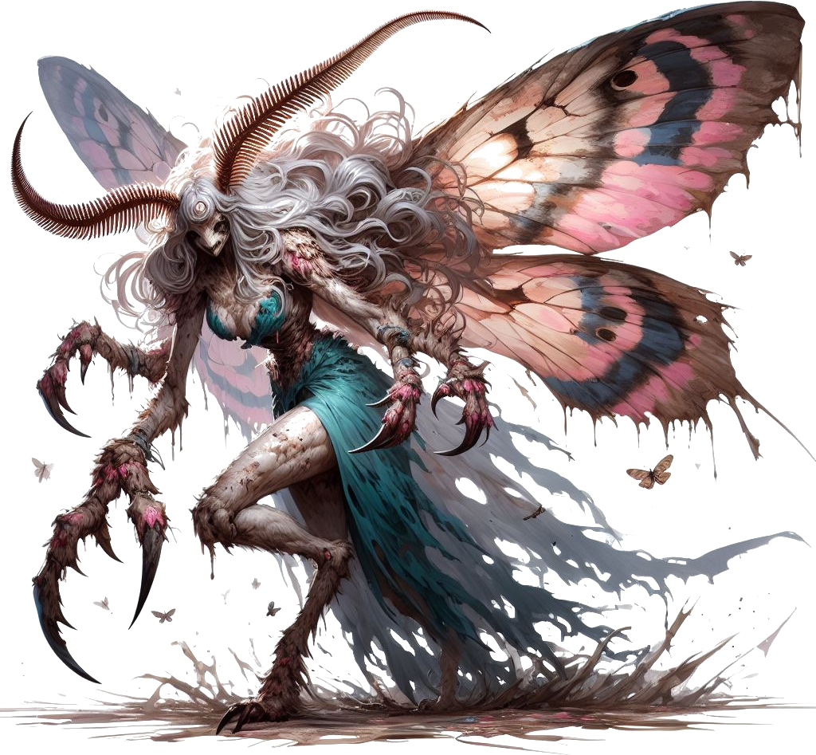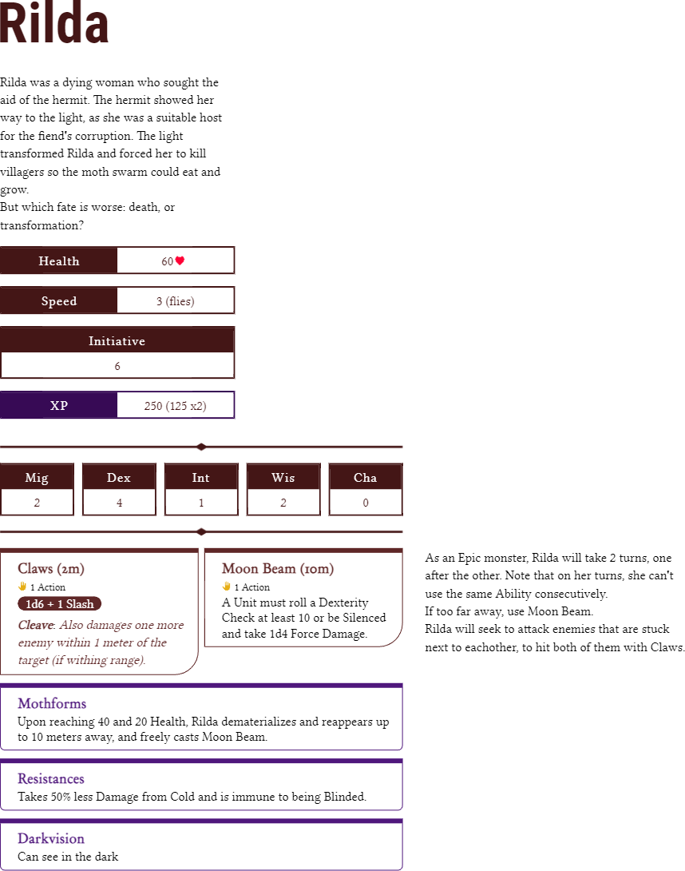

Remember to also narrate what Rilda does, and make sure the players understand that Claw will hit one more target near the main target.

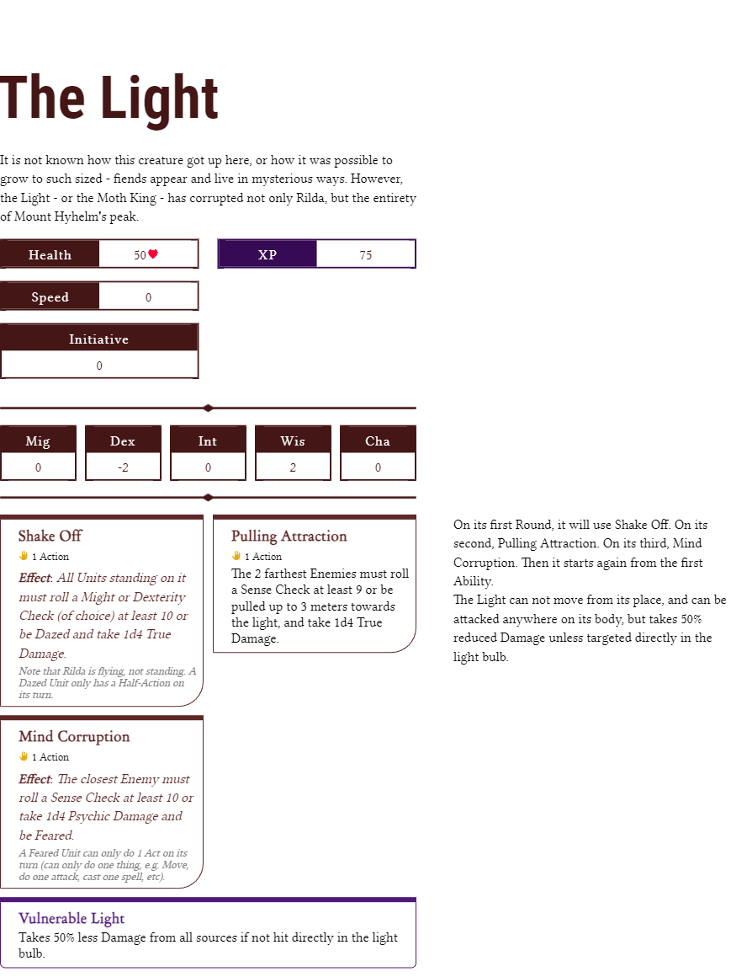

Rilda’s Death

## When Rilda Dies

*As the final blow lands upon Rilda, she staggers, her*

*strength waning as she collapses to the ground.*

*Gasping for air, she knows her time is fleeting and*

*recognizes she is on the verge of dying. She does not*

*resist anymore. With a last ounce of strength, she*

*manages to utter a whispered confession:*

*“I truly did love Tom…”*

*With those words, her body grows still, moth eyes*

*half closed, and hand talons unclenched. Her once-*

*majestic wings slowly lower onto her lifeless body and*

*cover her like a fine, white blanket.*

*Rilda, the moth queen, is dead.*

## When Moth King Dies

*With a final, resounding breath, the air around the*

*light crackles with energy emanating from its bright*

*lure. You feel the earth trembling as the fiend of light*

*loses its grip on life and slowly succumbs to death.*

## When Both Are Dead

*Soon, there is no more move or sound, as you are*

*surrounded by a white rain of moths falling dead from*

*the sky, all around the mountain peak.*

*There is now no more light. Your eyes take time to*

*adjust to the rather dark environment.*

*As you are contemplating the scenery, you notice a*

*strange feeling underneath your legs, as if you are*

*slowly sinking into the ground beneath you.*

*Harsh winds are starting to blow, taking the smooth*

*silvery insects with it, and raising a fine dust in the air.*

*The very land beneath you, the fiend, is starting to*

*disintegrate into a smooth powder, right under your*

*boots.*

*You take off quickly, making sure you’re not caught in*

*this strange storm of wind and moth dust. From afar,*

*you witness the very peak of the mountain*

*disappearing in a white blizzard.*

 *Moments later, it is no more. In its place - a clearing of*

*stone and dirt, the mountain now several meters*

*lower in altitude. But in its center you notice a tiny*

*glimmer.*

*As you believe it becomes safer, you go and*

*investigate. In the place of the giant luring fiend you*

*bested now lies a single white shining wing, no larger*

*than a finger nail. Gently cradling the moth wing I*

*your fingertips, you analyze it for any clues to its origin*

*and purpose. Through your magical senses, you discern*

*that it poses no immediate threat, and a glimmer of*

*potential power emanates from its delicate form.*

*There is not much else of interest on this plateau.*

Give the players the **Wing of the Moth King** from the appendix.

Players may use it to glide back to the village of Farwood.

Farwood Ending

## If they glide to Farwood…

*Tapping into the magic within the silvery moth wing,*

*you all invoke its power and leap from the mountain’s*

*edge. As you plunge into the open air, a pair of*

*spectral glowing moth wings unfurl from your back.*

*The sharp fall transitions to a slow descent, the wings*

*carrying you through the crisp mountain air towards*

*the village of Farwood below.*

*As you glide, the village grows larger with each passing*

*moment until it spreads out beneath you, just as it was*

*when you left. With a soft landing, your ethereal wings*

*retract, and you stand amidst the astonished villagers,*

*who gaze upon you with a mixture of awe and wonder.*

*Their eyes dart between you and the now-darkened*

*peak of Mount Hyhelm, as they no longer see a light*

*up on it.*

## If they hike back down…

*With a sense of relief, you begin your descent down the*

*mountain, confident that the challenging part of the*

*journey is behind you. Traversing the rocky path, and*

*navigating the treacherous snow terrain, you move*

*swiftly from checkpoint to checkpoint, retracing your*

*steps with ease.*

*Eventually, you reach the alcove the hermit called*

*home. The hermit, once a living presence in these*

*mountains, now stands unmoving against a wall,*

*its body turned to a solid gray material like stone.*

*You touch the stone figure, only to watch it crumble*

*into a fine dust at your finger tips. The wind carries*

*away the remnants of the hermit, scattering the*

*ashes across the mountainside.*

Feel free to give the players any useful items the Hermit has, and 1d100 more grams of the **Strange Dust**.

Players may revisit other locations they haven’t seen and get any valuable loot and information, but there will be no NPC interaction or combat (all enemies are turned to powdery stone).

 *You swiftly hike your way down the mountain with*

*practiced ease. As the hours pass by in a blur of motion,*

*you cover the distance as if they were mere minutes.*

*Finally, you reach the village of Farwood.*

*You stand amidst the astonished villagers, who gaze*

*upon you with a mixture of awe and wonder.*

*Their eyes dart between you and the now-darkened*

*peak of Mount Hyhelm, as they no longer see a light up*

*on it.*

## Villager Dialogue

*“You have returned! What was up there?”*

*“Did you find the mayor’s wife?”*

*“Where is the light gone?”*

*[If they used the wing] “How did you get those wings?”*

## Mayor Dialogue

*“You are back. What are the news?”*

*“I expect you’ve been through a lot. Here is the rest of*

*the gold promised. Feel free to keep whatever else you*

*found.”*

*“Have you seen any… woman? Dead, perhaps…?”*

*...Rilda? I expected as much… I spotted the beast*

*myself one day. Her image was in ingrained my mind*

*when I saw it… I did not believe what I saw was her.*

*It turns out it was. [you spot a tear falling down the*

*mayor’s face] But I assume life must move on. You did*

*a good thing. Saved more than one life, and for that,*

*we are all grateful.*

*…Hermit? I knew the hermit was somehow involved.*

*She let my wife pass to the light, did she? The light at*

*the end of the road was different for her.*

*I wonder what secrets the Hermit hid, or where she is*

*now.*

*...Light was a fiend? Goodness gracious! A fiend, on the*

*mountain? How did it get there? You did well to fight*

*the bloody beast. And to think it was part of the*

*mountain itself… unthinkable. Good riddance,*

*partner.*

*…Giant moths? I had no idea about them! I imagine*

*the monsters were being made from the sacrifices of*

*the poor villagers who died out there. Unholy*

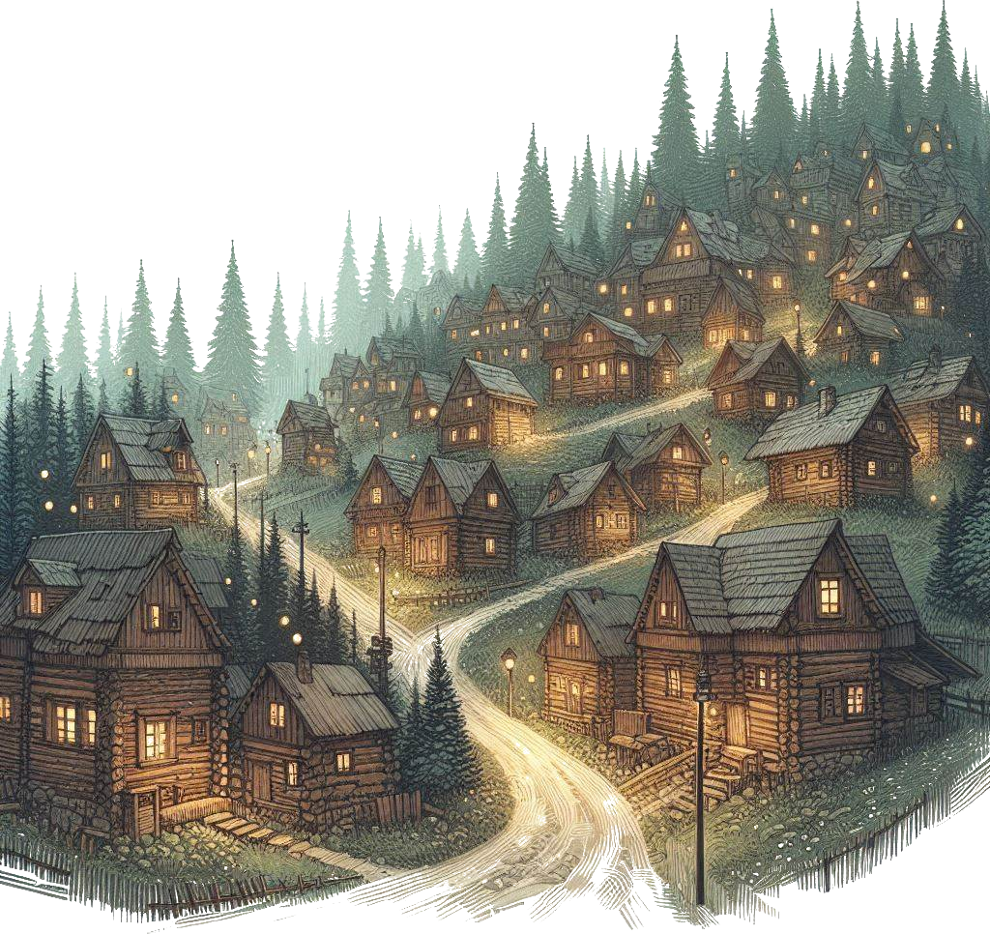*abominations.*

*…Moth swarm? So that’s why the light dimmed! It was*

*from all the moths covering it, swarming around the*

*light! I fear what may have happened if you hadn’t*

*resolved this in time.*

*…Moth queen? Moth king? Fiend? I never imagined it*

*would go so far. How was this possible?*

***[the mayor goes back to his desk, pulls out a sheet of***

***paper and hands it to you]*** *Here. There is a cleric out in*

*another village, several days away, called Whispervale.*

*If you happen to pass by that village, perhaps you can*

*gather some information on fiends. On that paper*

*are the instructions for how to reach Whispervale.*

*[Whispervale is a longer running campaign for*

*QuestGuard, which can be bought from the website*

*either as a PDF, or as a printed book. Whispervale can*

*act as a continuation of this adventure.]*

*“Heroes - I can’t expect to call you elsehow - thank you*

*for your service here in Farwood. I will make sure you*

*get free housing and warm meals at the inn. Take the*

*gold.”*

*The mayor quickly writes a check, gives it to one of the*

*guards and sends him off to another room. The guard*

*soon returns with a heavy pouch. Taking a look inside,*

*you find no less than 845 gold in coins of all types.*

*“Do what you will with it. It’s yours, you earned it. In the*

*meantime, I… I will need a moment. The village of*

*Farwood is ever grateful. We no longer have a light shine*

*upon our village. We don’t need one, and we don’t want*

*one.”*





